Quentin Wächter
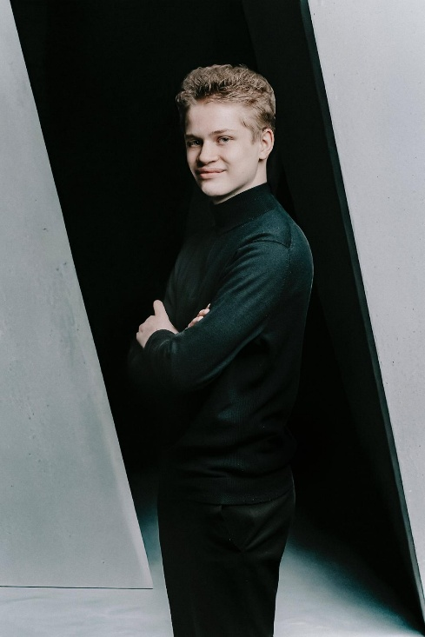

Quentin Waechter was born on the 1st of September 2009 in Solingen, Germany.
At the age of 3 he began playing piano under the guidance of his mother and at the same time took part in the early musical education program at the Solingen Municipal Music School. Piano lessons continued with Iva Jovanovic, Ulrich Eick-Kerssenbrock and Boris Radulovic at the Solingen Municipal Music School .In September 2024 Quentin started his piano lessons with Boris Radulovic at the Velbert Music and Art School.

Since 2015, Quentin has received the scholarship for the musically gifted children from the Solingen Music School Support Association and since 2025 from the Velbert Music and Art School Support Association.

In the summer semester of 2022, Quentin started studying music at the age of 12 at the Pre-College Cologne of the University of Music and Dance (HfMT), Cologne, where talented children receive in-depth musical training. He studies piano in the class of Prof. Dr. Florence Millet, harpsichord in the class of Prof. Michael Borgstede and continues piano lessons with Boris Radulovic. At the same time he attends the August-Dicke-Gymnasium in Solingen.

Since 2017, Quentin has participated in many national and international music competitions and won various prizes. He received first prizes in the following competitions:

- Regional competitions: Jugend musiziert (piano solo) 2017, 2020, 2023 and 2026, Germany
- Jugend musiziert Regional competition Mettmann and Federal State North Rhine Westphalia 2025 (duo with saxophone) and special prize for the performance of a modern piece from the German Association of Sound Artists (DTKV)
- Federal State North Rhine Wesphalia 2026 (piano solo)
- Josip Slavenski competition 2019, Belgrad (Serbia)
- 2nd and 3rd International Piano Competition 2020, 2021, Bitola (North Macedonia) / 2020 Laureat of the competition
- European Piano Competition Salentinae Terrae 2021,2022, Francavilla Fontana (Italy)
- X Amigdala International Music Competition 2021, Viagrande (Italy)
- IX, X, XI and XII Concorso Musicale Internazionale „Note sul mare“ 2021-2023, Rome (Italy) / 2022 absolute soloist prize / 2024 piano special prize
- 18th Concorso Internazionale Musicale Città di Pesaro 2021, Pesaro (Italy)
- 12th, 13th and 17th Concorso Musicale Internazionale Città degli Imperiali 2021, 2022 and 2026 Francavilla Fontana (Italy)
- VI. Concorso Internazionale di Musica Premio Città Murata 2021, Cittadella (Italy)
- 2nd, 3rd and 4th.International Classic Web Competition 2021-2023, Savona (Italy)
- Concorso Musicale Internazionale Città di Fasano 2021 (Italy)
- 4th Concorso Internazionale di Esecuzione Musicale Città di Sarzana, (Italy)
- 12th Concorso Pianistico Europeo Sonja Pahor, Fondi (Italy)
- 21st, 22nd, 24th and 25th International Festival-Contest for young musicians Lams Matera Award 2021, 2022, 2024, 2025 Matera (Italy), 2024 piano special prize and audience award;
- 1st Consorso Musicale Internazionale „Note sul mare“ Civitavecchia Estate 2022 Civitavecchia (Italy) / premio speciale pianoforte
- XIV and XVI Concorso Premio Crescendo 2023, 2026 Florence (Italy)
- XXXVI European Music Competition Città di Moncalieri 2024 / first absolute prize and Rosy Tondato Award (ex-aequo)
- X Competition Campus delle Arti 2025 Bassano del Grappa / Premio Campus (Italy)
- III International Music Competition „Giovanbattista Cutolo“ Nola (Naples)
- International Music Competition Città di Belluno 2026 (Italy)

Quentin's repertoire includes various works by J.S. Bach, W.A. Mozart,
L. van Beethoven, J. Haydn, S. Rachmaninov, A. Skriabin, , D. Scarlatti, F. Liszt,
F. Chopin, M. Ravel, R. Schumann, F. Schubert, G. Rossini, F. Mendelssohn,
J. Brahms, J. Sibelius, I. Albeniz, A. Piazzolla, F. Burgmüller, A. Diabelli,
S. Prokofjev, D. Schostakovitsch, A. Chatschaturjan, D. Kabalewski, S. Slonimski,
A. Casella, B. Bartok, G. Ligeti, A. Schönberg, G. Fauré, E. Satie, W. Byrd,
E. Morricone, T. Takemitsu, C. van Lunen, S. Barber, E. Dressel, P. Creston,
A. Louvier, M. Filotei.

Quentin regularly performs as a soloist and in ensembles at concerts and events. He has already performed various recitals in Germany and Italy (including Solingen Culture Night 2024 and Burger Bienale 2025, Solingen, Concert for the Camera Musicale Romana 2026,Rome ) and has performed in duo with saxophone and trio with violin and cello.
In October 2024, Quentin performed Johann Sebastian Bach's Concert No. 5 as a harpsichord soloist with the Pre-College Cologne Baroque Ensemble, and in June 2025, he performed Ludwig van Beethoven's 3rd Concert as a piano soloist with the Youth Symphony Orchestra of the Solingen Music School at the Solingen Theater and Concert Hall.
In July 2025, Quentin, winner of several "Note sul mare" of Rome competitions, participated in the Ardea Music Marathon and won a concert with the "Nova Amadeus Chamber Orchestra" of Rome directed by Maestro Stefano Sovrani in the 2025/2026 season.
Also in July 2025, Quentin participated in the Campus delle Arti competition in Bassano del Grappa and received the Premio Campus. He has won two recitals in Rome (Musicopaedia and Camera Musicale Romana), one each in Nizza (France) and Palazzo Balchik (Bulgaria), and a professional recording in for the "Musikstrasse" label.
In April 2026 Quentin won the first prize of the International Music Competition Francavilla Fontana and a recital for the Associazione Giovanile Musicale in Florence.
Quentin attended Masterclasses of the renowned pianists Michel Dalberto, Cédric Pescia, Massimiliano Ferrati and Anthony Spiri.

